Overall Theme: Personal, Social & Emotional Development
“Through play children wallow in ideas, feelings and relationships and become technical proficient through play”.

T. Bruce (1949 to present)
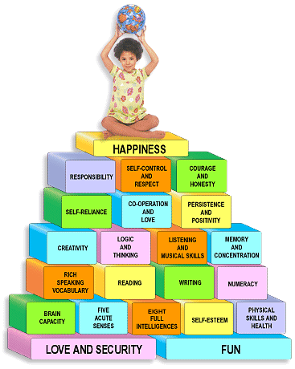

September – December 2020
All About Me (Equality & Diversity)

January – April 2021
The Way I Feel

April – August 2021
Moving Forward

