Meatballs in Tomato Sauce
Tomato Sauce
450g fresh tomatoes finely chopped or
1 x 480g tin chopped tomatoes
1 medium onion finely chopped
2 tsp. tomato puree
Salt and pepper to taste
1 tbsp. olive oil

- Pour oil in saucepan and add onion
- Cook for 2 minutes and add the rest of ingredients
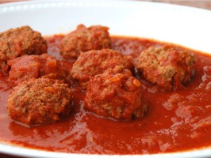
- Stir well and leave to cook slowly for ½ hour
- Check for taste and consistency

Meatballs

250g lean minced lamb
1 finely chopped onion
1 tsp. oregano
30g. fresh wholemeal breadcrumbs
1 tsp chopped or pureed garlic
1 tsp. barbeque sauce
Salt and pepper

- Put all the ingredients in a bowl or mixer and mix well
- Divide and shape the mixture into small balls
- Place on a well-greased tin
- Cook in a medium oven for about 45 minutes
- Remove from the oven, drain away the excess fat and add to the tomato sauce

Beans Burgers

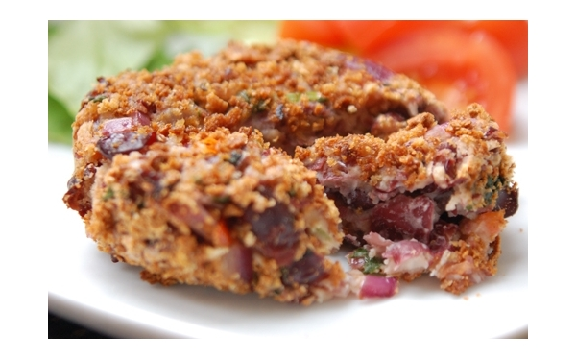
1 green pepper chopped
2 tbs. olive oil
1 onion finely chopped
1 carrot finely chopped
1 clove garlic crushed
½ tsp. ground coriander
½ tsp. ground cumin
2 x 800g tins mixed beans salad drained
1 tbsp. tomato puree
60g fresh wholemeal breadcrumbs
60g grated cheese (optional)

- Heat oil in a pan, add onion and cook for 5 minutes
- Add carrot, green pepper, garlic and spices and cook for 5 minutes, remove from heat
- Mash beans in a large bowl and add tomato puree and the onion mixture, and mix well
- Shape into burgers and place on a greased baking tray
- Cook for about 25 minutes in a preheated oven gas mark 6

Mixed Bean Stew

1 800g mixed bean salad
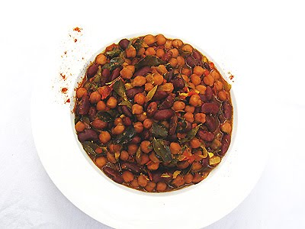
1 finely chopped onion
4 fresh tomatoes finely chopped
1½ pepper (red, green, yellow) diced
2 carrots diced
1 tsp tomato puree
1 tbsp. olive oil
1 tsp. crushed garlic
1 tsp. thyme
Salt and pepper to taste

- Cook onion in oil for 2 minutes
- Add garlic and cook for another 3 minutes
- Mix in tomato puree and add the rest of the ingredients plus the drained and rinsed beans
- Cook for ½ hour at gas mark 6 – stirring occasionally
- A just seasoning and serve

