Overall Theme: Understanding the World
“In play children construct their understanding of the world through direct experience with it”.

Froebel (1782 – 1852)
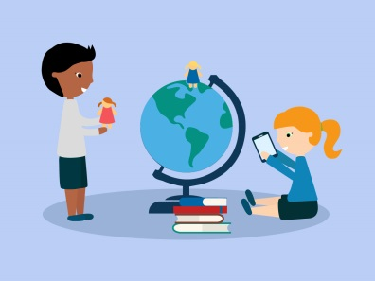

September – December 2019
Seasonal changes

January – March 2020
Habitats

April – August 2020
Friends of the earth

“There is no WIFI in the forest, but you get a better connection”.

