[](http://www.google.co.uk/url?sa=i&rct=j&q=&esrc=s&frm=1&source=images&cd=&cad=rja&docid=CoY_wsC5ArP2TM&tbnid=xahkkORDR7YDzM:&ved=0CAUQjRw&url=http://www.hdwallpapersplus.com/cool-backgrounds.html&ei=mqVVUszuLNOz0QW5tYGQDQ&bvm=bv.53760139,d.d2k&psig=AFQjCNFLnV7szodBCBqGOvtlM1DmoFKrLw&ust=1381428066817651)

**Friday 29th**

**October**



**With Bouncy castle and soft play**

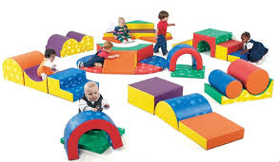

**9.00 am – 11.30am**

**\*0-8 years old**

**Stay & Play witH fancy HALLOWEEN costumes**

 [](http://www.google.co.uk/url?sa=i&rct=j&q=&esrc=s&source=images&cd=&cad=rja&uact=8&ved=0CAcQjRw&url=http://www.letscelebrateparties.com.au/costumes-fancy-dress-c-58/&ei=_PWUVcuYDovX7Qa40ZfwAg&bvm=bv.96952980,d.ZGU&psig=AFQjCNGXN-TSAdDdvimuEaoU7U9pHcENdg&ust=1435911369199680)

**Come and have fun and bring your Trick or Treat Bag!**

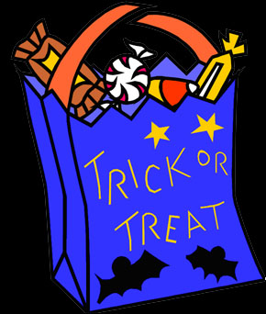

**\*0-8** **year olds**

**1.30 pm – 3.00 pm**





**Monday 25th**

**October**

**Messy Play with a Creative Workshop for Black History Season**



**\*0-8 year olds**

**9.00am – 11.30am**

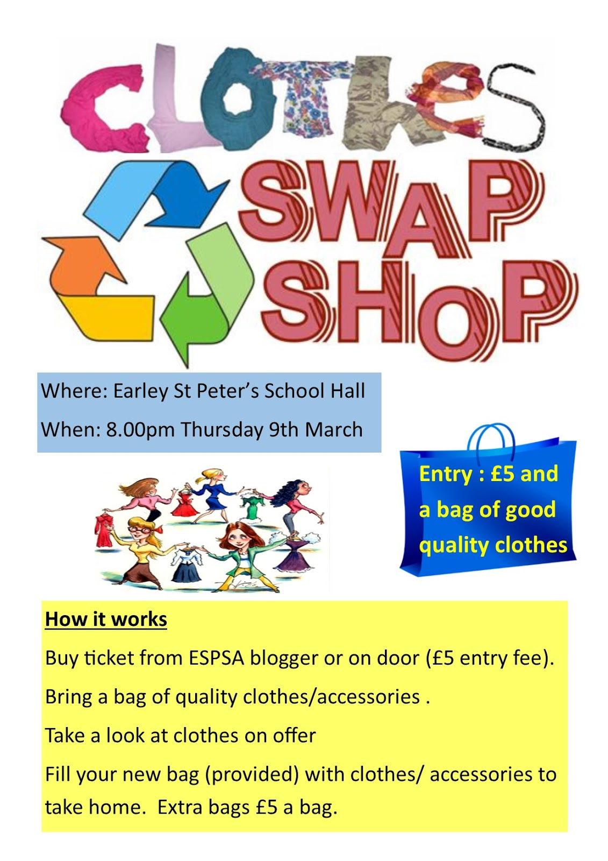

**Come along to our Clothes Swap and you won’t be able to stop. Bring in your unwanted clothes and accessories and swap them for items you love!**



**\*0-8 year olds**

**9.00am – 11.30am**

**FREE Vitamins for pregnant women, new mothers and children up to age4** **If you are not in receipt of vitamins please call the centre to speak to a member of staff.**





**Are you having difficulty providing food for your family?** **If so speak to a member of staff**

**Tuesday 26th**

**October**



**\*0-8** **year olds**

**9.00am – 11.30am**

**“The Story of Sankofa the wise man & his friends”**

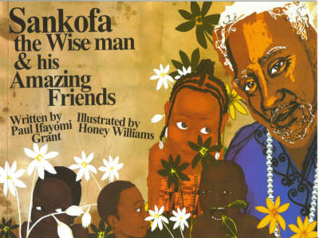

**By Paul Ifayomi Grant**

**Come along and join in on our interactive story session from 10.30am – 11.00am**

**Around the world in music**

[](http://www.google.co.uk/url?sa=i&rct=j&q=&esrc=s&source=images&cd=&cad=rja&uact=8&ved=0CAcQjRw&url=http://www.mpsaz.org/mesa/staff/bravilesviey&ei=FzuRVazOM6eR7Aauv6qoBA&bvm=bv.96783405,d.ZGU&psig=AFQjCNFGTIMVOmQuZZ0meuhlFnrc-S7j7A&ust=1435667517000421)

**£1 donation for this session**

**\*0-30 months from**

**1.00pm – 1.45pm**

**\*30 months – 8 years old from 2.00pm – 2.45pm**

**Snack time from**

**1.45pm – 2.00pm**

**Thursday 28th**

**October**

**Under 18 months**

**Drop-in**



**9.00 am – 11.30 am**

**Wild Walk**

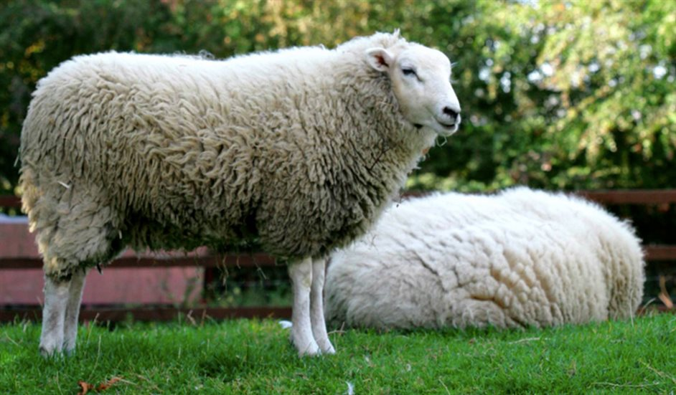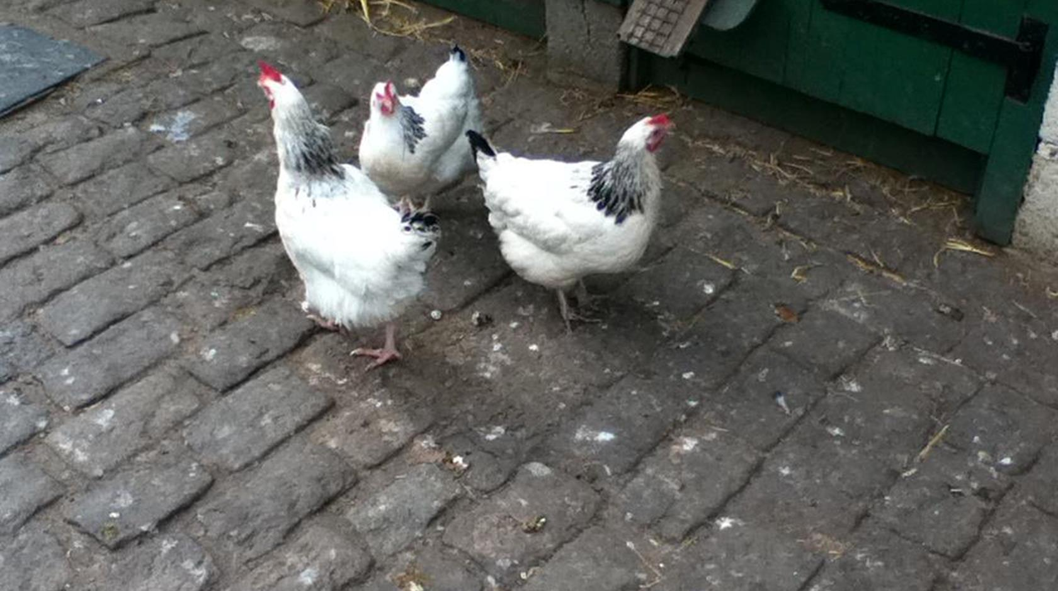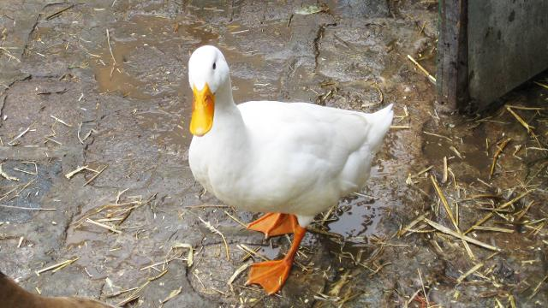

**To**

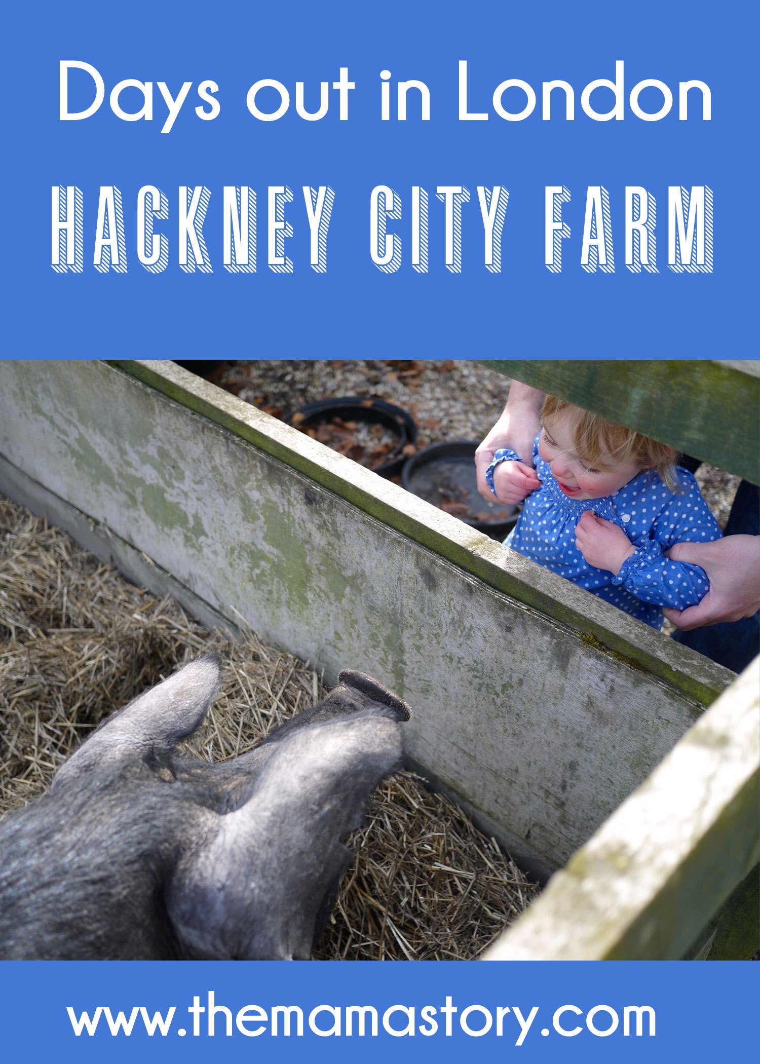

**10.00 am – 12.00 noon**

**\*0-8 year olds**





**\*\* Last admission for**

**AM sessions – 10.30am**

**PM sessions – 2.00pm**

**Wednesday 27th October**

[](http://www.littlecooks.co.nz/)

**“From around the world”**

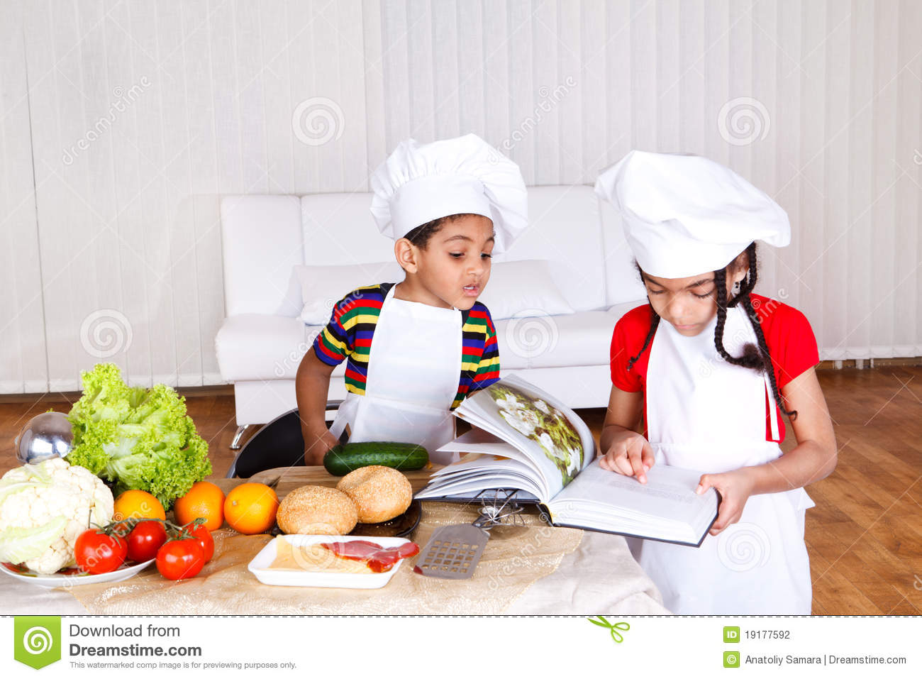[](http://www.123rf.com/photo_10892109_international-foods-and-cuisines-of-the-world-represented-by-a-restaurant-chef-hat-and-flags-of-coun.html)****

**\*0-8 year olds**

**9.00 am – 11.30 am**

[](http://www.google.co.uk/url?sa=i&rct=j&q=&esrc=s&source=images&cd=&cad=rja&uact=8&ved=0CAcQjRxqFQoTCNjV-ZqhlckCFQk6FAodgqgLeg&url=http://www.horshamlifesavingclub.co.uk/baby/&psig=AFQjCNHn1KkJxR9HGpj8MbwVw5WJ_HOcwg&ust=1447773971796518)

**Workshop for Parents and Carers with crèche provided**



**\*0-5 year olds**

**1.30 pm – 3.00 pm**

(**Please book as there are limited spaces)**

**COVID -19 UPDATE**

**You will be asked to wear a mask when entering the centre at all times. We will continue to follow the social distancing guidance. Temperatures will be taken on arrival and you will be asked to follow the centre’s procedures. Thank you for your co-operation and support.**



Parents and Black History Week

2021

Image result for food bank----------------------------

[](http://www.google.co.uk/url?sa=i&rct=j&q=musical+notes&source=images&cd=&cad=rja&docid=LdE2HB7XBMIA2M&tbnid=8hzx-0QA4dinPM:&ved=0CAUQjRw&url=http://www.officialpsds.com/Music-Notes-PSD62920.html&ei=CnveUZ-FHYjJ0AXEroCwBA&bvm=bv.48705608,d.d2k&psig=AFQjCNH7Vkj1um-zzgy-HIA221U4BzIUGg&ust=1373621271376433)[http://www.easyvectors.com/assets/images/vectors/afbig/252826a789ef1c4718b2c246d00a576f-sixteenth-notes-joined-in-a-pair-clip-art.jpg](http://www.google.co.uk/url?sa=i&rct=j&q=musical+notes&source=images&cd=&cad=rja&docid=Gscedch0KF_lmM&tbnid=hNKCIbiqWYPm2M:&ved=0CAUQjRw&url=/url?sa=i&rct=j&q=musical+notes&source=images&cd=&cad=rja&docid=Gscedch0KF_lmM&tbnid=hNKCIbiqWYPm2M:&ved=&url=http://www.easyvectors.com/browse/music/252826a789ef1c4718b2c246d00a576f-sixteenth-notes-joined-in-a-pair-clip-art&ei=l3reUeSHB6G40QW844DQDw&bvm=bv.48705608,d.d2k&psig=AFQjCNH7Vkj1um-zzgy-HIA221U4BzIUGg&ust=1373621271376433&ei=t3reUZC_OvL50gX4mIHoAQ&bvm=bv.48705608,d.d2k&psig=AFQjCNH7Vkj1um-zzgy-HIA221U4BzIUGg&ust=1373621271376433)