

**Monday**

**1st April 2024**

**CENTRE**

**CLOSED**



EASTER

MONDAY

**Tuesday**

**2nd April 2024**

**£1 donation for this session**

**\*0-30 months from**

**9.30 am – 10.15 am**

**\*30 months – 8 year olds from**

**10.15 am – 11.00 am**

**Snack time from**

**11.00 am – 11.30 am**



**With My Journey Celebration**

**1.00 pm – 3.00 pm**

**\*0-8 year olds**

**Wednesday**

**3rd April 2024**





**\*0-8 year olds**

**9.00 am – 11.30 am**

[](http://www.google.co.uk/imgres?imgurl=http://www.horshamvoluntaryaction.org/wp-content/uploads/2014/12/CAB-logo.jpg&imgrefurl=http://www.horshamvoluntaryaction.org/horsham-citizens-advice-bureau-volunteer-recruitment-evening/&h=1063&w=1063&tbnid=tvpLRTWB7aIknM:&docid=g1i_RzEw46HvjM&ei=TTxBVtzePMi3O83MuZgE&tbm=isch&ved=0CEQQMygTMBNqFQoTCJy5tNPOhMkCFcjbDgodTWYOQw)

**10.00 am -1.00 pm**

**(Every 1st Wednesday**

**of each month)**

**By appointment only**



**Are you having difficulty providing food for your family?**

**If so speak to a member of staff**

**Volunteers are always needed**

http://www.vcscymru.org.uk/wp-content/uploads/2013/01/volunteers.jpg**Wouldyou like to gain experience in the workplace to help you when applying for jobs. Please call Miza**



**Are you having difficulty providing food for your family?**

**If so speak to a member of staff**

**FREE Vitamins for pregnant women, new mothers and children up to age 4**

**If you are not in receipt of vitamins please speak to a member of staff.**



**Thursday**

**4th April 2024**



**\*0-8 year olds**

**9.00 am – 11.30 am**

**With Toy/Book Library**

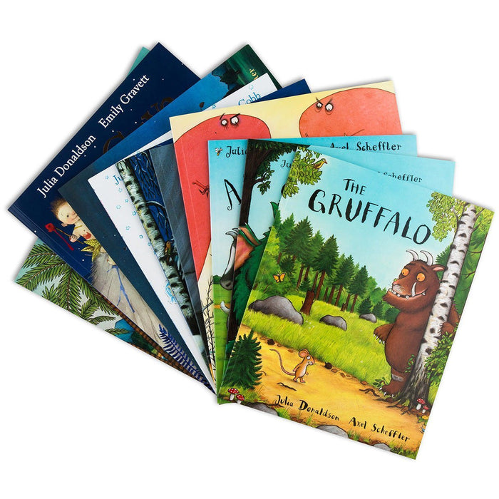



**\*0-8 year olds**

**1.00 pm – 3.00 pm**

**Accident & Prevention Scheme**

**Get advice about keeping your**

**Child/ren aged 0-5 year olds safe.**

**Please call Miza to check your eligibility and receive a free**

**assessment on your home for Safety gates, Cupboard/Draw locks, Blind cord covers and Corner Cushions.**  **Please call Miza **





**RATED**

**“OUTSTANDING” IN ALL AREAS**

**2019**

**Mapledene & Queensbridge Children’s Centre**

**54, Mapledene Road, Hackney E8 3LE Tel: 020 7249 8139**

**If you or family require any additional support or advice please contact Pamela or Miza at the centre on 0207 249 8139 or pamela.phipps@mapledenecc.co.uk** [**miza.myers@mapledenecc.co.uk**](mailto:miza.myers@mapledenecc.co.uk)

**Friday**

**5th April 2024**



**With Bouncy & soft play**



**\*0-8 year olds**

**9.00 am – 11.30 am**

**Come along to our daily Clothes Swap and you won’t be able to stop. Bring in your unwanted clothes and swap them for items you love!**



**RATED**

**“OUTSTANDING” IN ALL AREAS**

**2019**





**Do you have a child aged**

**12-24 months? Come and speak to Nasima, Mirembe or Scarlett to join our Bookstart Corner programme.**

**\*A £1 donation would be greatly appreciated**



**Monday**

**8th April 2024**



**With Physical Literacy**

**\*0-8 year olds**

**9.00 am – 11.30 am**

**Toileting workshop**

**1.00 pm -3.00 pm**

**Crèche provided, please book a space**

1. **months - 5 years**

[](http://www.google.co.uk/url?sa=i&rct=j&q=&esrc=s&source=images&cd=&cad=rja&uact=8&ved=&url=http://nspt4kids.com/connect-with-nspt/more-resources-and-downloads/&ei=mPGUVZn9KsOC7gbksIHYAg&bvm=bv.96952980,d.ZGU&psig=AFQjCNGRUFjEXaS4TNx688QYWuvuopddSg&ust=1435910937184723)[](http://www.google.co.uk/url?sa=i&rct=j&q=&esrc=s&source=images&cd=&cad=rja&uact=8&ved=0CAcQjRw&url=http://www.jkp.com/uk/ready-set-potty.html&ei=JPKUVeLKNITP7QaBuqD4Ag&bvm=bv.96952980,d.ZGU&psig=AFQjCNGRUFjEXaS4TNx688QYWuvuopddSg&ust=1435910937184723)

**Volunteers are always needed**

http://www.vcscymru.org.uk/wp-content/uploads/2013/01/volunteers.jpg**Would you like to gain experience in the workplace to help you when applying for jobs. Please call Miza**

**Alive and Kicking Football Library at Mapledene**

**Need a football?**

**Borrow one for free! We simply ask that you bring the ball back so that others can enjoy it.**

**Please call to speak to a member**

**Tuesday**

**9th April 2024**



**£1 donation for this session**

**\*0-30 months from**

**9.30 am – 10.15 am**

**\*30 months – 8 year olds from**

**10.15 am – 11.00 am**

**Snack time from**

**11.00 am – 11.30 am**



**1.00 pm – 3.00 pm**

**\*0-8 year olds**

**With Toy/Book Library**







**Wednesday**

**10th April 2024**





**\*0-8 year olds**

**9.00 am – 11.30 am**



**Are you having difficulty providing food for your family?**

**If so speak to a member of staff**



**Do you have a child aged**

**12-24 months? Come and speak to Nasima, Mirembe or Scarlett to join our Bookstart Corner programme.**



**RATED**

**“OUTSTANDING” IN ALL AREAS**

**2019**

**Thursday**

**11th April 2024**

A trip to Mudchute Farm

[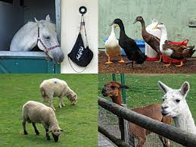](http://www.google.co.uk/imgres?imgurl=http://3.bp.blogspot.com/-lVwMem4JoW8/UDk4r_NkkLI/AAAAAAAAIyk/WoGE-TI3_uo/s400/mudchute.jpg&imgrefurl=http://diamondgeezer.blogspot.com/2012_08_01_diamondgeezer_archive.html&h=300&w=400&tbnid=IaFLowv4PX9dhM:&zoom=1&docid=z-e4qVxyusGQ_M&ei=WNLxVMf5FoO5UZKOguAK&tbm=isch&ved=0CDIQMygqMCo4rAI)

**9.30 am – 2.30 pm**

**Please bring an oyster card & a packed lunch**



**Accident & Prevention Scheme**

**Get advice about keeping your**

**Child/ren aged 0-5 year olds safe.**

**Please call Miza to check your eligibility and receive a free**

**assessment on your home for Safety gates, Cupboard/Draw locks, Blind cord covers and Corner Cushions.**  **Please call Miza **

**Friday**

**12th April 2024**



**With Bouncy castle and soft play**



**\*0-8 year olds**

**9.00 am - 11.30 am**

**Mapledene’s Play Street session**



1. **pm - 3.00 pm**

**Come along to our daily Clothes Swap and you won’t be able to stop. Bring in your unwanted clothes and swap them for items you love! **

**INSET CENTRE CLOSURE ON**

**MONDAY 15TH APRIL**

**REOPEN ON TUESDAY 16TH APRIL 2024**

**Mapledene & Queensbridge Children’s Centre**

**54, Mapledene Road, Hackney E8 3LE Tel: 020 7249 8139**

**If you or family require any additional support or advice please contact Pamela or Miza at the centre on 0207 249 8139 or pamela.phipps@mapledenecc.co.uk** [**miza.myers@mapledenecc.co.uk**](mailto:miza.myers@mapledenecc.co.uk)