Beef or Lamb And Spinach Cannelloni – Serves 4

175 g/6 oz spinach, coarse stalks removed
55 g/2 oz butter
1 ½ tbsp. olive oil
2 shallots finely chopped
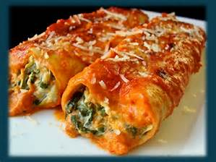
2 garlic cloves finely chopped
225 g/8oz fresh mince beef or lamb
115 g/4 oz Parmesan cheese finely grated
4 ½ tbsp. double cream
1 egg lightly beaten
pinch of dried oregano
4 tbsp plain flour
175 ml/6 fl oz milk
16 no pre-cook cannelloni tubes
1 quantity Tomato Sauce
Salt and pepper

Method

Cook the spinach in just the water clinging to the leaves for 5-8 minutes until tender, then drain and squeeze out as much liquid as possible, chop finely

Melt 15 g/ ½ oz of butter with the oil in large frying pan. Add the shallots and garlic and cook over a low heat, stirring occasionally for 5 minutes until softened, add the meat increase the heat to medium and cook, stirring frequently and breaking it up with a wooden spoon for 8-10 minutes until evenly browned. Add the spinach and cook for 3-4 minutes. Transfer the mixture to a bowl and stir in 3 tbsp. of the Parmesan, 1 ½ tbsp. cream, the egg and oregano. Season to taste with salt and pepper.

Preheat the oven to 190°C/375°F/Gas Mark 5. Melt 25 g/1 oz of the remaining butter in a saucepan, then stir in the flour and cook, stirring constantly for 2 minutes. Remove the pan from the heat and gradually stir in the milk and remaining cream until smooth. Return the pan to the heat and bring to boil stirring constantly. Remove from the heat.

Fill the cannelloni tubes with the meat mixture. Pour a little of the tomato sauce over the base of an overproof dish,then put the cannelloni in the dish in two layers. Spoon the white sauce over them and top with the remaining tomato sauce. Sprinkle with the remaining Parmesan and dot with the remaining butter. Bake in the preheated oven for 30 minutes. Serve immediately

