

**Friday**



**With Bouncy & soft play**



**9.00 am - 11.30 am**

**\*0-5 year olds**



**9.30 am – 12.pm**

**(Term Time Only)**



**Come along on the 1st Friday of each month, to our Road safety awareness event.**

**Evaluation**

**Have you attended more than three services in Cluster F?**

**If you have, we would love to know your views and ideas. Please see any member of staff to book an evaluation session.**

**Remember… your views do matter!**



**Are you having difficulty providing food for your family?**

**If so speak to a member of staff**

**Tuesday**



**With Rachel**

**£1 donation for this session**

**\*0-2 years from**

**9.30 am – 10.15 am**

**\*2-5 year olds from**

**10.15 am – 11.00 am**

**Snack time from**

**11.00am – 11.30 am**

**First Steps**

**(Referral only)**

**9.00am – 5.00 pm**

**Jewellery Class**

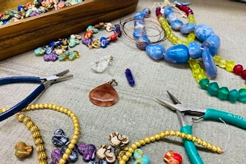

**9.30 am – 12.00 pm**

**Starts 23/04/24 – 02/07/24**

**(10 weeks)**

**No crèche**

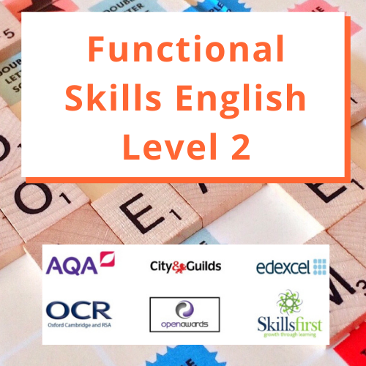

**1.00pm – 3.00 pm**

**Come along to our daily Clothes Swap and you won’t be able to stop. Bring in your unwanted clothes and swap them for items you love!**



**\*A £1 donation would be greatly appreciated.**

**Monday**





**With Physical Literacy**

**9.00 am - 11.30 am**

**\*0-5 year olds**

**Sewing Class**



**9.30 am – 12.00 pm**

**Starts 22/04/24 – 01/07/24**

**(10 weeks)**

**No crèche**

**First Steps**

**(Referral only)**

**9.00am – 5.00 pm**

**Volunteers are always needed**

http://www.vcscymru.org.uk/wp-content/uploads/2013/01/volunteers.jpg**Wouldyou like to gain experience in the workplace to help you when applying for jobs. Please call Miza**

**FREE Vitamins for pregnant women, new mothers and children**

**up to age 4**  **If you are not in receipt of vitamins please speak to a member of staff.**

**On the 1st Monday of each month, bring fresh fruits to share with others during our Messy play session.** 

**Wednesday**

[](http://www.littlecooks.co.nz/)

**\*0-5 year olds**

**9.00 am – 11.30 am**



**Citizens Advice Bureau**

[](http://www.google.co.uk/imgres?imgurl=http://www.horshamvoluntaryaction.org/wp-content/uploads/2014/12/CAB-logo.jpg&imgrefurl=http://www.horshamvoluntaryaction.org/horsham-citizens-advice-bureau-volunteer-recruitment-evening/&h=1063&w=1063&tbnid=tvpLRTWB7aIknM:&docid=g1i_RzEw46HvjM&ei=TTxBVtzePMi3O83MuZgE&tbm=isch&ved=0CEQQMygTMBNqFQoTCJy5tNPOhMkCFcjbDgodTWYOQw)

**10.00 am -1.00 pm**

**(Every 1st Wednesday)**

**By appointment only**

**Bookstart Corner**

**1.30 pm – 2.30 pm**

**For parents & their 12 – 24 months old children**

**By appointment only**



**1.00pm – 3.00pm**



**(Referral only)**

**9.00 am – 5.00 pm**

**On the 2nd Wednesday of each month, come along to have a chat with our Family support Practitioner.** **9.30am – 11.00am**

**Thursday**

**Under 18 months**

**Drop-in**



**10.00 am – 11.30 am**

**Information, Advice & Guidance drop-in**

**10am -11.30am****

**(Every 2nd Thursday of each month)**

**Getting Ready for School**



**Early Literacy Workshops**

**9.00am - 10.00am**

**For parents & their 3-4 year old children**

**Speech & Language**



**(Referrals only)**

**9.00 am – 5.00 pm**

**EYE Childcare NCFE Level 3 Course**



**10.00 am – 3.00 pm**

**NCFE CACHE Level 2 Certificate in Health & Social Care**



**10.00 am – 3.00 pm**

**(Every 3 & 4 Thursday)**



**Mango Room staff:**

**Nasima Begum –**

[**nasima.begum@mapledenecc.co.uk**](mailto:nasima.begum@mapledenecc.co.uk)

**Mirembe Nambi –**

[**Mirembe.nambi@mapledenecc.co.uk**](mailto:Mirembe.nambi@mapledenecc.co.uk)

**Scarlett Freebairn –**

[**scarlett.freebairn@mapledenecc.co.uk**](mailto:scarlett.freebairn@mapledenecc.co.uk)

**If you or your family require any additional support or advice please contact Pamela or Miza at the Centre on**

**02072498139 or Email pamela.phipps@mapledenecc.co.uk**

**Miza.myers@mapledenecc.co.uk****denecc.co.uk**

**Address:**

**54 Mapledene Road, Hackney, London, E8 3LE**

**Serving Families in Hackney**

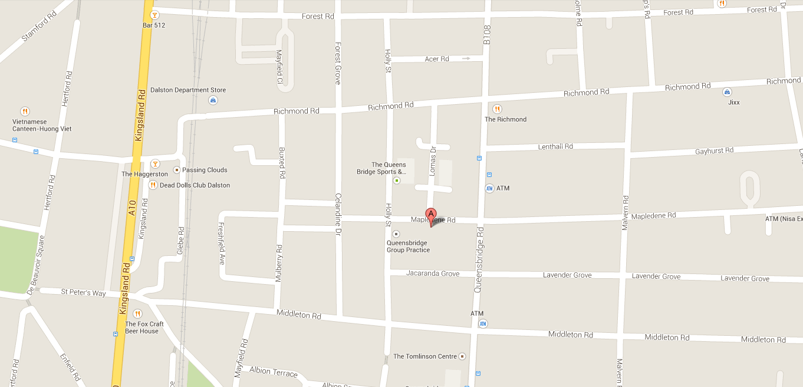





**Please scan for direction to the centre**

**Please scan for programme of activities**

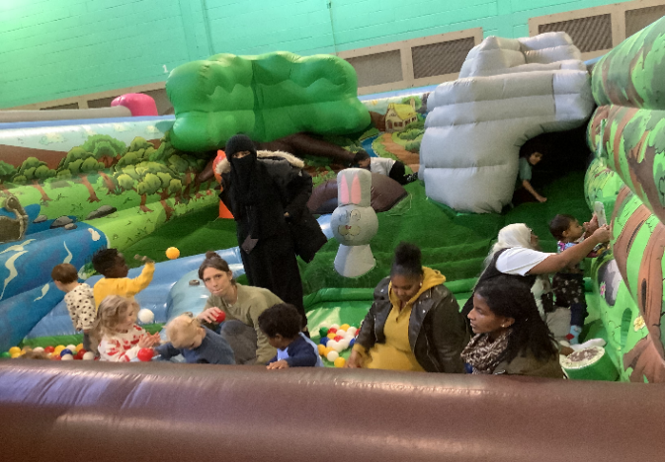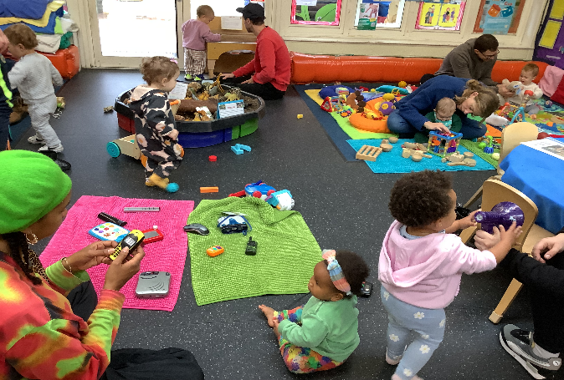

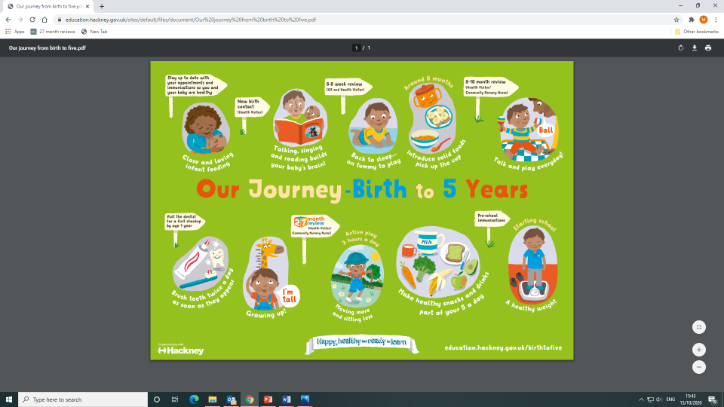

**Five To Thrive**

To

Thrive



**Working for every child: Follow us on** **@ mapledenecc**